2017 Kaw Wrestling Camp June 26-28
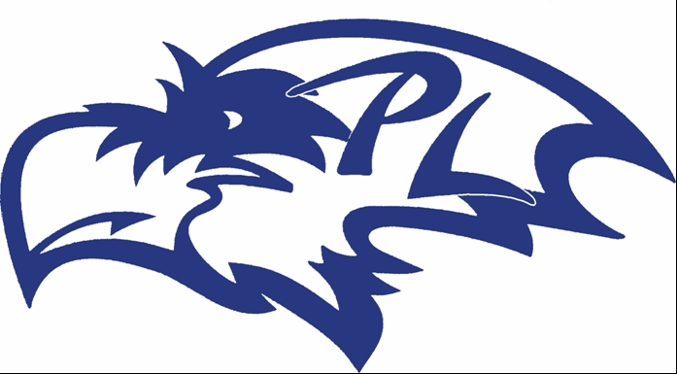
Split Session:
Grades (7-12) 9 a.m. - Noon
Grades (K-6) 6 p.m. - 8 p.m.
- Come join us in the wrestling room at PLHS for a three-day training camp.
- Competitions and gear giveaways!
- The cost is $15 for three days of technical instruction and live match opportunities!
- Guest clinicians will include:

  - Colby Crank: National Champion, Assistant Wrestling Coach, Baker University
  - Victor Hughes: National Champion, Baker University
  - Courtney Strauss: 3x NAIA National Qualifier, Assistant Wrestling Coach, Bethany College
Bring your $15 and waivers the first day of camp! Make checks out to: David Roberts

Waiver Statement:
The undersigned states that he/she understands that the participant will engage in an athletic activity and that there is potential risk of injury. The undersigned has examined the potential risks, assumes the risks and understands and agrees that the coaches of PLHS/PLMS and USD 343 are not and shall not be responsible for or liable for and injury or illness to person or damage to property resulting from the activity in which the participant is enrolled, and the participant and undersigned, hereby forever release and hold harmless the coaches of PLHS/PLMS and USD 343 of all claims of any kind that the participant, the undersigned, or their respective heirs, executors, administrators or assigns may have or claim to have resulting from participation in said activity.

Name of Participant _______________________ Grade 2016-17 ________

Signature of Parent/Guardian _________________________________

