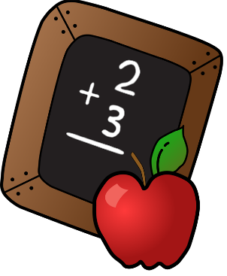
Second Grade News
September

Second graders will be working of the following curriculum topics:
Language Arts: Nouns, Author’s Purpose, Realism/Fantasy
Math: Addition and Subtraction Strategies
Social Studies: People and Places
Health: Getting Along, Your Body

We have some exciting special events coming this month:
September 4: No School (Labor Day)
September 13: Picture Day
September 15: Homecoming Parade (2:00)
September 18: PTO Meeting (6:30 @ PES)
September 25: No School (Teacher Inservice)
September 28: American Royal Field Trip

Reminders:
Spelling words and sentences will come home each Monday. The final test will be given Friday. It is important to review the spelling list with your child throughout the week.
Along with spelling review, it is always helpful for your child to practice reading and math facts.
Students will need to wear clothing appropriate for standing and walking on our American Royal Trip. They will need a sack lunch.

