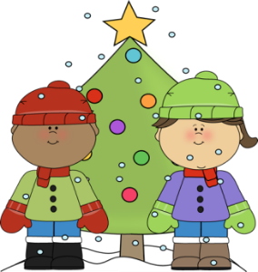
Second Grade News
December

Second graders will be working on the following curriculum topics:
Language Arts: Verbs, Compare/Contrast
Math: Adding and Subtracting Two-Digit Numbers
Science: Properties of Matter
Social Studies: Ways of Living
Health: Keeping Clean and Fit

We have some exciting special events coming this month:
December 15 Winter Music Program (6:30 @ PLHS)
December 16 Pajama Day
December 20 Winter Party (2-2:50)
Dec. 21- Jan 2 Winter Break
January 3 No School (Teacher Workday)

Reminders:
- Work with your child to review addition facts. Students are working to earn an ice cream celebration before winter break.
- Make time to pick up a book and read with your child over break. It will be extra important to practice at home since your child will not be reading at school.

