September 2016



The staff at both PES and LES “Welcome” you to the 2016-17 school year. I feel very fortunate to be working with a dedicated staff that is ready to meet the needs of our students.

This year we have added 3 new teachers: At first grade Sydney Allen and Grace O’Trimble. Our Instructional Specialists have also changed. Kim Yoder has been added to the LES staff and Amanda Feuerborn has moved to this position at PES.

We have three teachers who will be having additions to their families this school year: Amanda Feuerborn will be on maternity leave from mid Novemeber to mid February – Debbie Sack will be her substitute; Grace O’Trimble will be on maternity leave from the end of December to mid February – Rachel Hamm will be her substitute and Allison Day will be on maternity leave from mid March until the end of the year. While these individuals are absent I have every confidence that the substitute teachers will continue to provide quality instruction to your children.

Our enrollment numbers for this year: PLPK:30, PES:90, LES:148

It was wonderful to see all of the familiar faces and some new ones at our annual Sneak Peek and Back to School events. This is a great time to meet the teacher and relieve any anxiety about the school year.

Teachers continue to develop and refine learning and teaching strategies that will have a positive educational impact on your children. We will continue to implement the following assessment tools to measure academic growth as well as develop specific learning strategies to meet the needs of our students: MAP – Measurement of Academic Growth: grades 2-4th; AIMSweb reading & math screener: grades PK -1st.

**PLES PTO:** Officers are: President Megan Baranski, Vice President Mardi Bowlin and Secretary Jamie Newman. PTO is looking for an individual to assume the Treasurer responsibilities. Minutes are available on the district web site or through the PTO Facebook page. We meet once a month on Monday evenings 6:30 pm @ Perry Elementary. Specific dates are on the elementary web page calendar. This is an active group and they are planning many exciting events for your children! PTO’s main objective is to assist student learning through educational field trips. Each grade level attends two events per year. As you can imagine the cost accumulates rapidly.

**Back to School Night** – was a success! We had approximately 45% of PLES parents in attendance. If you were unable to attend – please contact your child’s teacher. I’m sure she has important information to share with you.

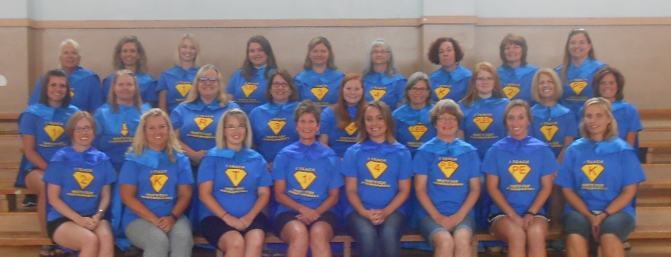Should you have any questions, please feel free to contact me at either school. My schedule will be such that I will spend a half day in each building every day. It is my desire to continue a positive connection with all participants. We are all enjoying our ‘Super Hero’ theme for the year. I am looking forward to an exciting year at PLES.



Principal

**A message from Love & Logic (Jim Fay):**

Do you want your children to be the ones who easily give up when assignments get difficult…or do you hope they’ll have the confidence and grit required to keep going when the going gets tough?  What’s going to best prepare them for tomorrow’s extremely competitive workforce? Will it be high grades because they only took the easier classes…or will it be somewhat lower grades earned by finishing a more challenging course of study? What’s most important: stellar grades or solid perseverance and skills?  
   
As this school year begins, let’s give our children the gift of seeing that satisfaction and growth come from facing challenges. **1. Focus on the strain rather than the brains** – instead of praising, ‘You are so bright,” notice their successes and ask, “How did you do that?” **2. Help them blame their success on effort and perseverance** – most children will respond to “How did you do that?” with “I don’t know.” When that happens, ask a question: “Did you work hard or did you keep trying?” Both options in this question point directly to strains not brains. **3. Avoid placing them on a pedestal** – children need to know that many things in life will be challenging and they need to have the skills to meet those challenges and not avoid them. **4. Show them that failure is not final**…it’s informative – do your best to laugh about your blunders and demonstrate how you learn from your mistakes. **5. Love them unconditionally** – when our children know that we love them, they feel safe to make the mistakes required to become truly exceptional people.

|  |  |
| --- | --- |
|  |  |

**School Hours For safety reasons, students should not arrive at either school before 7:40 am.** Breakfast is served from 7:45 to 8:10am. Please keep in mind that school starts at 8:10 am! Anyone arriving after 8:10 is considered tardy and will need to go to the office upon arrival to obtain an admit slip. It is very important for children to attend school regularly so that they will be able to gain the necessary skills for successful grade level advancement.

MCED00167_0000[1]

**Daily Transportation:** It is our intent to keep all children safe during this process. Please remember to notify the office of a change in transportation for your child **before 2:00 pm**. Our 1st dismissal time begins at 3:05 pm and it is important that the office receives transportation changes in a timely manner. Thank you in advance for helping us to make transportation flow as smoothly as possible.

By now parents should know what the classroom expectations are concerning homework. I would like to reinforce the following:

* Homework should be completed by the student.
* Parents should provide a quiet environment with minimal assistance.
* Homework should be reinforcing previously taught skills.
* The length of homework should follow these basic guidelines, unless your child did not use their classroom time appropriately: K-5/10 min, 1st- 10/15 min, 2nd-15/20 min, 3rd- 20/30 min, and 4th- 30 min.
* Homework should not be a struggle between parents and children. If this is happening, put the homework up and let your child deal with his/her teacher the next day at school. It would also be beneficial for you to talk with the classroom teacher if you are having issues at home.
* If your child states that they do not have any homework, they can do one of the following:

\*read to themselves or read aloud to someone

\*practice math facts

* Sometimes the most valuable lesson children are experiencing with homework is learning responsibility and the completion of tasks.

**District Wide expectations for behavior at ALL sporting events**

In an effort to maintain a SAFE and ORDERLY environment at our home sporting events, so that ALL fans can enjoy the games, USD #343 Perry-Lecompton is asking parents to please help us in our effort by reviewing these expectations with their children before they attend a home football or basketball game.

* For safety reasons, please leave footballs, soccer balls, kick balls, etc. at home when attending football games. They may be confiscated by game supervisors. Ball playing, tag games, etc. will not be allowed at home football and basketball games.
* We encourage all students to be seated during the game and supporting their team.
* Concessions are available at all sporting events. After going to the concession stand, students should return to their seats.
* Always exhibit good sportsmanship.  
        \*Be respectful during the National Anthem, school songs, and player introductions.  
        \*Never boo or yell at officials or opposing players.  
        \*Cheer for your team’s players.   
        \*Represent your school in a positive manner.   
        \*Be respectful of other students and adults attending the game.

Remember, you should be going to the game to watch the game and support your team.

**Up Coming School Events:**

**9/5: NO School – Labor Day**

**9/19: PLES PTO mtg. 6:30 pm @ PES**

**9/21: 2nd grade Field Trip to American Royal**

**9/22 & 23: Bald Eagle Rendezvous in Lecompton**

**9/23: PLHS Homecoming Parade 2pm**

**9/26: NO School – Teacher In-Service**

**9/27: PLES Site Council 6 pm @ LES**

**9/30: Career on Wheels field trip – 3rd grade**

