PLPK, PES & LES News

Mark your calendars for these important events!
10/3: 3rd Grade Career on Wheels Day @ PLHS 12:30-2:00
10/6: Little Girl Cheer Night & 2-4th graders to sing the National Anthem @ PLHS Football game.
10/9: BoE mtg. @ DO 6:30 pm
10/11: Parents lunch with students
10/13: 4th grade to Science City 8:30-2:30
10/16: PLES picture retakes
10/17: End of 1st 9 weeks – Bus Driver Appreciation Day!
10/18: No School for PLPK: PLPK Parent Teacher Conferences 8:30 – 8:00 pm
10/18: 4-8pm: PLES Parent Teacher Conferences
10/19 & 20: No School
10/19: 2-8 pm: PLES Parent Teacher Conferences
10/23: PLES PTO mtg. @ PES 6:30 pm
10/25: 6:30 pm: 2nd grade music program @ PLHS Theater
10/27: PLPK Field Trips to Shaake’s Pumpkin Patch: 8:15 am & 12:30 pm
10/27: Kindergarten to Shaake’s Pumpkin Patch 9:00- 12:00
10/31: Halloween parties & parade: PES 12:45 – 1:45; LES 2:00-3:00

"Recipes for Success" is this year's National School Lunch Week theme, and to celebrate on Wed. October 11th parents are invited to have lunch with their students. In keeping with this year's theme, the student’s at LES voted for one of my favorite meals…Spaghetti and Cheese Pie!
Safety One of my highest priorities is to provide a safe and secure learning environment at the elementary schools. During the first weeks of school PES & LES students and staff have practiced tornado and fire drills and lock down drills. Please remember when you are visiting the schools: 1) always use the front entry to check in and out of the office and 2) wear a visitor’s badge.
Parental Involvement in School: When you think of parent involvement, do you picture moms & dads volunteering in classrooms? That’s only one way to help. Research shows that supporting your child’s education at home is even more important. Below are some conversation starters to use with your child to engage them about their school day: 1) “Let’s see what you brought home!” Always go through your child’s book bag and discuss their papers and read over notes from the school. 2) “Show me what you have for homework!” Your child should be able to explain to you what they are supposed to do – it is the parent’s job to provide a ‘distraction free’ place for them to complete the work. 3) “Describe a book you enjoyed today!” This gives you the idea of what your child likes to read. Encourage reading and listening skills by reading aloud to your children. 4) “Tell me something you’re learned that you’d like to know more about!” Use your child’s interests as family activities. When families are engaged in learning activities with their children students make greater academic gains. Building partnership with families is a priority for PLES. We are looking forward to 100% attendance during parent teacher conferences.
A Message from Dr. Charles Fay – Love & Logic
Clearly, most children are growing up in a more challenging world than we ever imagined. The consequences of mistakes are more serious than ever. Of great concern is the fact that many children are not being equipped with the survival skills necessary for making wise decisions about these pressures. More and more children seem to believe that bad things can’t really happen until after their second or third poor decision. What do I mean? Perhaps an example will best illustrate this point.
Not long ago, I took my son to the movies. As we sat through the multitude of previews and ads for giant-sized, butter-flavored popcorn, I noticed two boys sitting near the front, throwing ice. Their parents were seated about three rows behind them. Mom walked up to them and said something like, “You stop that. I mean it. That’s one.” A minute or two later, the ice once again began to sail. This time Dad approached them and said very loudly, “Mom told you to stop that. Now that’s two.” Soon, the popcorn began to fly. Dad rushed back down to them and said, “Stop that. If you keep doing that, we’re going to have to leave!” Finally, after three or four warnings, these parents put some action behind their threats and took their children home. What happens when we give children two or three warnings before we deliver a consequence? We condition them to believe that they always can make at least two poor decisions before anything unfortunate happens. Does this give children a strong defense against peer pressure? Absolutely not! Why? Because down deep they start to develop thoughts inside their heads that say things like, “I can do something wrong at least two times before anything bad happens.” Love and Logic parents know that children need to understand that bad things can happen after the first poor decision — without repeated warnings. How do they teach this? They set limits once and follow through with meaningful consequences rather than more warnings.
What’s this look like in the movie theater? Mom or Dad walk over and whisper, “Are you guys going to be able to behave or do we need to go?” If the boys act up again, Mom and Dad don’t lecture or warn. Instead, they say something like, “How sad. We’re going home now. And by the way, how are you guys going to pay us for the money we spent on tickets, soda, and popcorn? You can tell us later. Try not to worry about it.”
PLES Site Council: This council is designed to acquire knowledge about school programs and procedures; help communicate the school’s vision and purpose to the public and engage in thoughtful dialogue about the performance of the school. PLES Site Council consists of the following individuals:
Jarae Essman jarae.essman@gmail.com, Stephanie Confer Stephanie.confer@gmail.com.
RJ Brown rjbrown122@gmail.com, Stephanie Armbrust sarmbrust@sarmbrust.com
Lavell Winsor lavellwinsor@gmail.com Lee Kelley CLKelley@gamil.com

PLES Face book: Remember to keep up with some of the latest information through the Perry Lecompton Elementary or PTO pages as well as your classroom pages!

Please continue to check the district web site for up to date information www.usd343.org
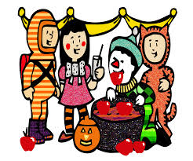
I truly appreciate your support of our schools!

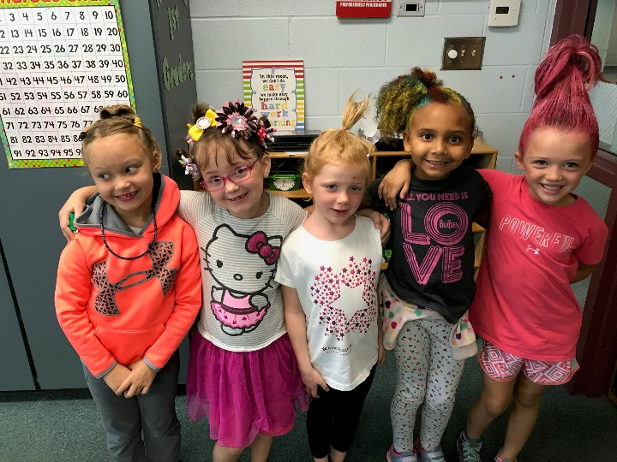

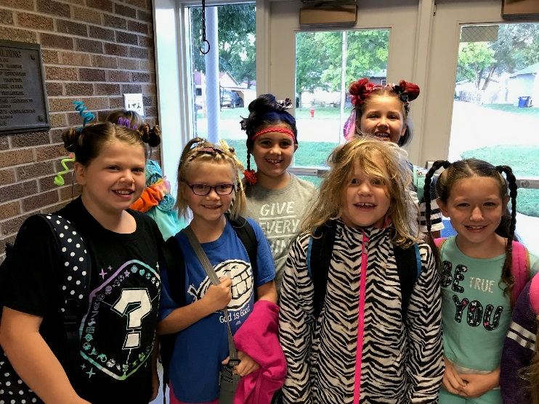

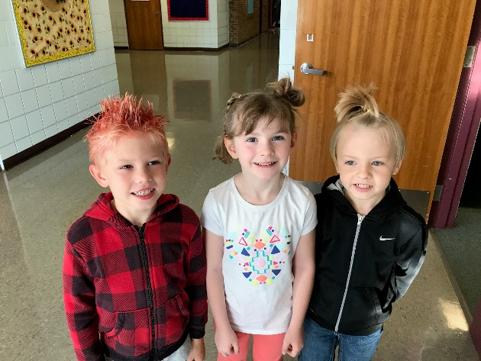
Crazy Hair Day!

