May 2018

May Events:
5/1 – 5/4: MAP Assessments for 2, 3, 4 grades
5/1 - 5/11: AIMSweb Assessments for K-1 grades
5/3: Kindergarten to Topeka Discovery Center
5/4: PLPK visits Topeka Zoo; 4th gr. visits PLMS 12:45 pm
5/7 - 5/11: Teacher Appreciation week
5/11: 4th gr. Store 9:00 am; Kindergarten Music and Recognition Program: 2:00 pm @ PES
5/14: 2nd gr. to Lawrence Art Center & Prairie Park Nature Center; PTO mtg. 6:30 pm @ PES
5/15: 1st gr. & Kindergarten visit LES
5/17: 1st gr. to KU Natural History Museum; 3rd grade to Kaleidoscope and Sea Life Aquarium
5/18: Field Day: AM PES: 9:30 – 10:15, PM LES: 12:15-2:30
5/22: 4th gr. Recognition & Music Program: 6:30 @ LES Gymnasium
5/23: PLPK End of the Year Pot Luck Breakfast and Lunch Celebration
5/23: Last Day of school – regular dismissal
School News: In an effort to keep expenses down, PES will be giving families the option of picking up end of the year grade cards at the school office May 31st & June 1st. Cards not picked up will be mailed June 5th. LES grade cards are emailed.
Once again we are entering our last month of school for the year. I appreciate your efforts to encourage positive learning experiences for your children. Please remember to pay off all school debts (enrollment & lunch fees) by the end of the year. Any remaining balances will be forwarded on to the next school year. Wishing you all a wonderful summer break!
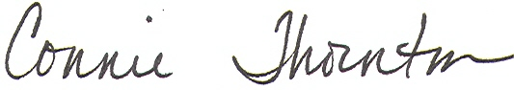

Field Day for K-4 PES & LES: May 18
This year's Field Day will be held at each school: PES: am and LES pm. Students from both elementary schools will be participating in a variety of events & games which will showcase their talents. This will be a great opportunity for all elementary students and parents to enjoy themselves. If you would like to assist with the event, please contact the school office or Jill Bradney jbradney@usd343.org
Kelsey Singleton ksingleton@usd343.org

PLES PTO:
2018-19 Officers:Mardi Bowlin, President; Zebbie Starnes, Vice President; Sharie Hohn, Secretary and Meghan Baranski, Treasurer. PTO works diligently to support grade level field trips and special treats for the teaching staff…new members are always encouraged!!!!
LES 4th grade students…wishing you a great summer and terrific 5th grade year! Good Luck at PLMS!

Mrs. Gantz’s Class: Devin Aldrich, Josh Allensworth, Daniel Callahan, Casey Journey, Sophia Copeland, Ryland Reeeman, Lindsey Hurd, Jayda Jessepe, Kelsey Jones, Lucas Marcum, Samuel McCoy, Dayton Morris, Tanner Nally, Jarritt Otter, Jaclyn Riley, Andrew Root, Michael Scruggs, Bailynn Slagel, Madison Smith, Spencer Stansell.

Mrs. Surface’s Class: Lola Agre, Eddie Andrews, Colton Bahnmaier, Anthony Baker, Ronnie Baker, Josie Boyden, Jordyn Davis, Wyatt Garber, Bailey Leochner, Garrett Metcalfe, Jacob O’Trimble, Hunter Pennel, Rylie Rosenberger, Maggie Ross, Mary Jo Steele, Dayton Tucker, Arianna Wolford.

Mrs. Johnson’s Class: Mya Ayala, Jacob Baranski, Avery Brown, Hutson Buttram, Kaleb Confer, Trevor Conklin, Lia Essman, Chance Gray, Mackenzie Hackathorn, Dominick Hatcher, Blane Haverkamp, Cael Hetrick, Kadyn Hoffman, Cheyenne Jones, Kinsley Juedes, Malakie Laws, Olivia Messerschmidt, Mollie Moseley, Rilliey Smith, Ben Veronie.
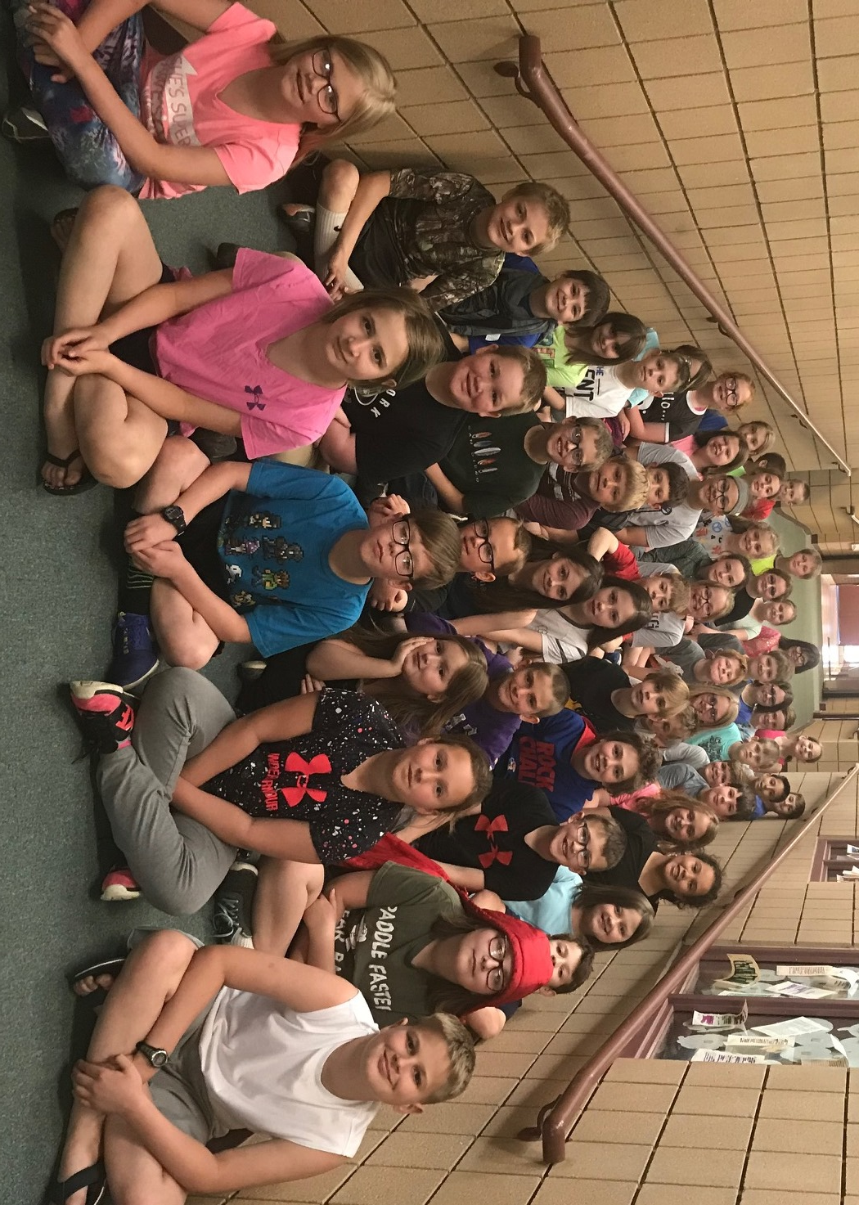

4th Grade Music and Recognition will be held on
5/22 @ 6:30 pm LES Gymnasium

For your efforts and time to help provide a quality education for our students!


